|  |  |
| --- | --- |
|  | EUROPEAN COMMISSION  Executive Agency for Small and Medium-sized Enterprises (EASME)  Department A - COSME, H2020 SME and EMFF  **Unit A3 - EMFF** |

**Agreement number: EASME/EMFF/2015/1.2.1.1/SI2.709624**

**Project Full Name: Monitoring the Ocean Climate Change with Argo**

European Maritime and Fisheries Fund (EMFF)

MOCCA

D4.4.3 Argo App for data reading, plotting and comparison

|  |  |
| --- | --- |
| Circulation: | PU: Public |
| Lead partner: | OGS |
| Contributing partners: | Euro-Argo ERIC |
| Authors: | Giulio Notarstefano and Nicola Creati |
| Quality Controllers: | Sylvie Pouliquen, Romain Cancouët |
| Version: | 0.2 |
| Reference | D4.4.3 Argo App for data reading, plotting and comparing v0.2.docx |
| Date: | 18.02.2020 |



**Istituto Nazionale di Oceanografia e di Geofisica Sperimentale**



**Euro-Argo ERIC**

European Research Infrastructure

(2014/261/EU)

**©Copyright 2020: The MOCCA Consortium**

Consisting of:

|  |  |  |  |
| --- | --- | --- | --- |
| Organisation/Natural person | Represented by | Statute | Contributing entities[1] |
| Euro-Argo ERIC | N/A | Coordinator | N/A |
| The French Republic | Ifremer | Member | SHOM, INSU/CNRS, Meteo-France, IRD, IPEV |
| The Federal Republic of Germany | BSH | Member | GEOMAR, University of Hamburg, Alfred-Wegener-Institute for Polar and Marine Research (AWI) |
| The Hellenic Republic | HCMR | Member | N/A |
| The Italian Republic | OGS | Member | N/A |
| The Kingdom of the Netherlands | KNMI | Member | N/A |
| The Republic of Finland | FMI | Member | N/A |
| The United Kingdom of Great Britain and Northern Ireland | Met Office | Member | NOCS, BODC, PML |
| The Kingdom of Norway | IMR | Member | N/A |
| The Republic of Poland | IOPAN | Observer | N/A |
| The Republic of Bulgaria | IO-BAS | Member | University of Sofia, National Institute of Meteorology and Hydrology |

This document may not be copied, reproduced, or modified in whole or in part for any purpose without written permission from the MOCCA Consortium. In addition to such written permission to copy, reproduce, or modify this document in whole or part, an acknowledgement of the authors of the document and all applicable portions of the copyright notice must be clearly referenced.

All rights reserved.

This document may change without notice.

Document History

|  |  |  |  |
| --- | --- | --- | --- |
| Version[2] | Issue Date | Stage | Content and Changes |
| 0.1 | 05.02.2020 | Draft | Initial document creation |
| 0.2 | 18.02.2020 | Draft | Revision |
| 0.3 | 00.00.2020 | QC | For internal quality control |
| 1.0 | 00.00.2020 | Final | Final version for submission |

Table of Contents

1. Introduction 6

2. THE ARGO APP 7

2.1. TECHNICAL DESCRIPTION 7

2.2. HOW TO USE THE ARGO APP 8

3. Conclusion 26

Table of Figures

Figure 1: launch of the Argo App in the MATLAB Command Window. 8

Figure 2: main dashboard of the Argo App. 9

Figure 3: window for float profiles selection. 10

Figure 4: steps for float profiles selection. 11

Figure 5: “Plot data” button in the main dashboard. 12

Figure 6: selected float profiles in the main dashboard. 13

Figure 7: TS diagram of the selected float profiles. 14

Figure 8: selection of a particular float profile (profile 055 in bold red) in the main dashboard and in the TS diagram. 15

Figure 9: setting up the thresholds for the comparison between the selected float profile and the reference dataset. 16

Figure 10: Location of the float profile (black diamond) and location of the reference profiles, color-coded per time difference with the float profile. 17

Figure 11: float and reference salinity profiles color-coded as defined in figure 10. 18

Figure 12: float and reference TS profiles color-coded as defined in figure 10. 19

Figure 13: salinity float profile (black line) and the closest (in time) reference profile (red line).. 20

Figure 14: TS float profile (black line) and the closest (in time) reference profile (red line). 21

Figure 15: location of the float profile (black diamond) and the closest (in time) reference profile (red diamond). 22

Figure 16: salinity float profile (black line) and the closest (in space) reference profile (red line). 23

Figure 17: TS float profile (black line) and the closest (in space) reference profile (red line). 24

Figure 18: location of the float profile (black diamond) and the closest (in space) reference profile (red diamond). 25

# Introduction

This document describes the application that has been developed by OGS to support the activities related to the Delayed-Mode Quality Control (DMQC) of the MOCCA Argo fleet in the Mediterranean and Black Seas.

The DMQC of MOCCA floats is performed by Euro-Argo MOCCA delayed-mode operators according to the area of deployment and taking into account their areas of expertise. It is further described in the deliverable D4.1.1 “Organization of Float Data Management among DAC and DM-operators”.

OGS is responsible for the DMQC of the temperature and salinity data of the MOCCA floats deployed in these two marginal seas and it is co-responsible in the Southern Ocean.

The DMQC processing is described in the deliverable D.4.3.1 “Report on Delayed-Mode processing on the MOCCA fleet”.

The application developed is called Argo App (AA) and it is part of a deliverable in WP4 of the MOCCA project. The AA is a user friendly tool that reads the Argo NetCDF files, converts the files in MATLAB format, allows Argo profiles selection, produces graphs of temperature and salinity, performs a tailored comparison between the float and reference profiles and provides the main information of float profiles.

# THE ARGO APP

The AA tool has been developed with MATLAB (version R2017b) and it has been tested on both LINUX and Windows platforms. It requires the use of the MATLAB Mapping Toolbox (<https://it.mathworks.com/products/mapping.html>). The AA has been built in MATLAB environment using an Object-Oriented Programming (OOP). The App allows to select specific float profiles to be compared with the reference dataset. Moreover, it provides with several diagrams in support of the DMQC analysis. Technical details are given in chapter 2.1 and a description on how to use the app and its outputs is provided in chapter 2.2.

## Technical description

The AA exploits the OOP features of MATLAB to couple analysis algorithms with a Graphical User Interface(GUI). The program differs from common MATLAB scripts since it creates a user-driven space where a user can interact with the app, for instance, by entering text or by clicking a button. Every action is followed by a function call (callback function) and the execution of some code. Callbacks are short functions that must obtain some data to do their job, update the app if necessary and store results for other callbacks. The app is just a container and a manager of small functions needed to get a larger task. MATLAB offers a GUIDE, an interface to create interactively the GUI but it provides only a small set of widgets. AA has been built from scratch by hand and depends on two main classes:

* ArgoUI: it is the main GUI object that creates the main graphical interface and provides the user with every options and information needed to load, visualize and analyse data.
* ArgoPlot: it manages plots of profiles and the interaction with them through the user mouse pointer. For instance, plotted profiles can be selected with the mouse and compared with reference profiles.

The plotting windows are standard MATLAB figure plots. Custom plot windows could be created but they provide less features of the standard MATLAB ones. ArgoUI and ArgoPlot use some external callback functions (defined in a separate source file) to operate on profiles.

## How to use the Argo App

The AA is launched by typing “argo” in the MATLAB Command Window (Figure 1).

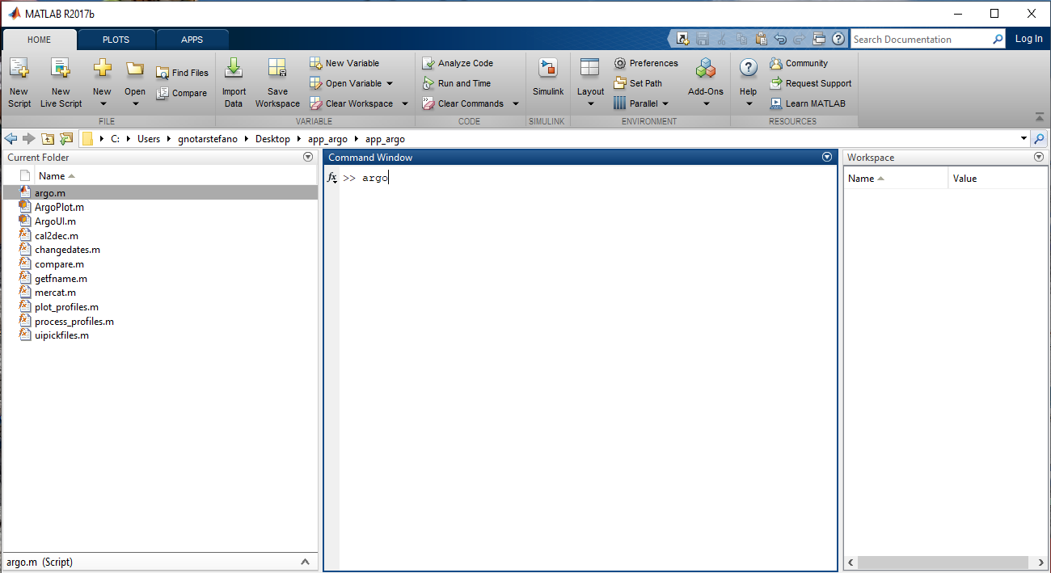

Figure 1: launch of the Argo App in the MATLAB Command Window.

The main dashboard (Figure 2) appears after a while and allow to load the NetCDF files of a specific float.

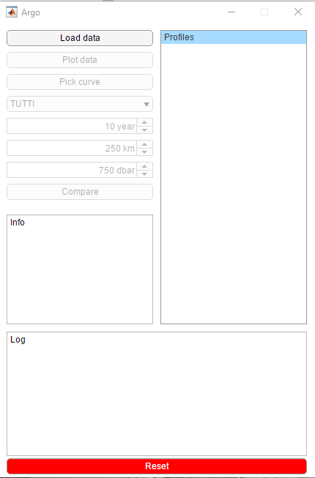

Figure 2: main dashboard of the AA.

The user has to click the “Load data” button. A window for the float selection is shown (Figure 3).

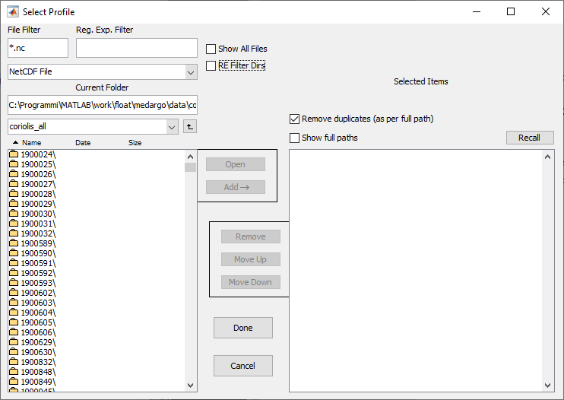

Figure 3: window for float profiles selection.

After a double click on the preferred float folder and a double click on the “profiles” folder, the user can select a group of profiles with the mouse and then click the “Add” button. To complete the procedure, click on “Done” button (Figure 4).

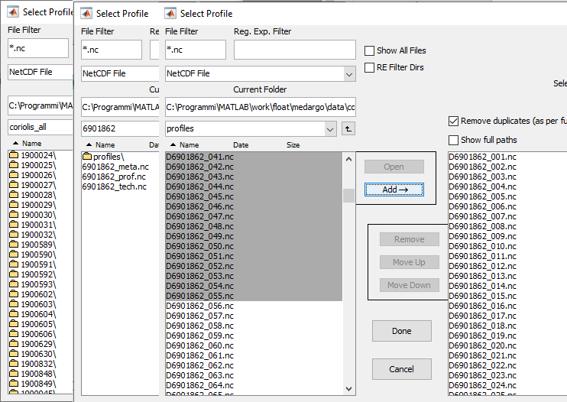

Figure 4: steps for float profiles selection.

At this point, the “Plot data” button in the main dashboard is clickable (Figure 5).

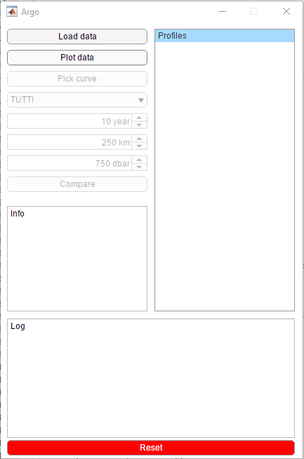

Figure 5: “Plot data” button in the main dashboard.

Once the “Plot data” has been clicked, the selected profiles are converted in MATLAB files and are shown on the right side of the dashboard (Figure 6) and a TS diagram color-coded per time (cycle number) is produced in a MATLAB figure (figure 7).

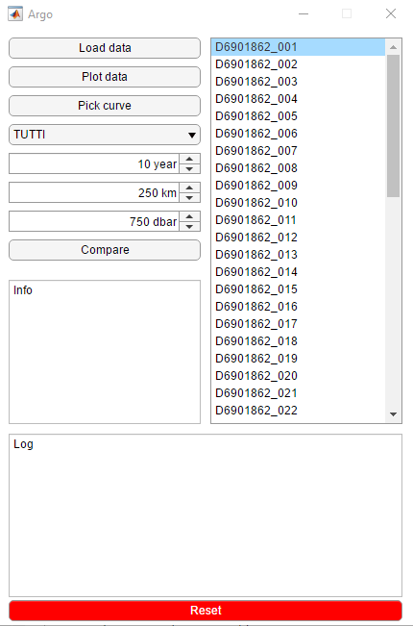

Figure 6: selected float profiles in the main dashboard.

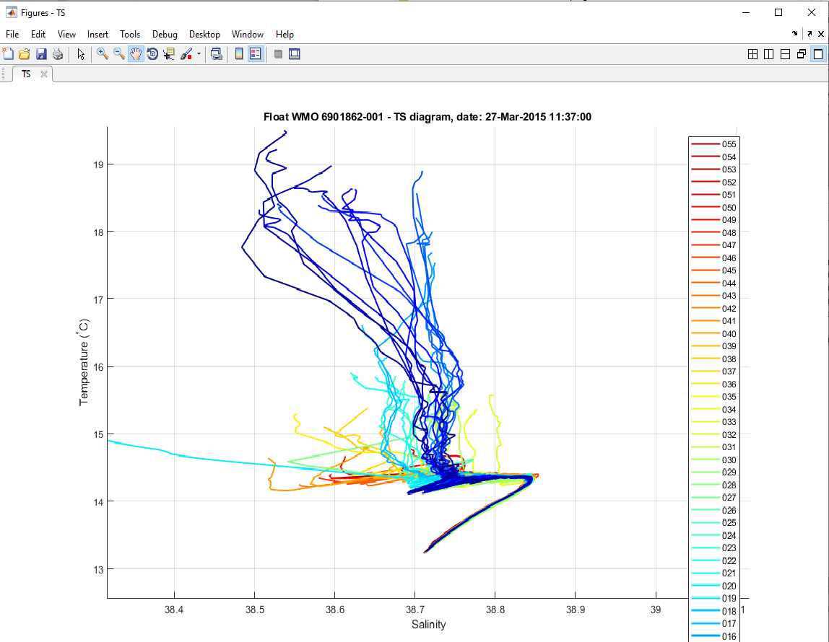

Figure 7: TS diagram of the selected float profiles.

The user can then select a particular profile in two ways: clicking the “Pick curve” button on the main dashboard and then selecting the profile in the TS diagram with the mouse or simply selecting the profile in the dashboard with the mouse (Figure 8).

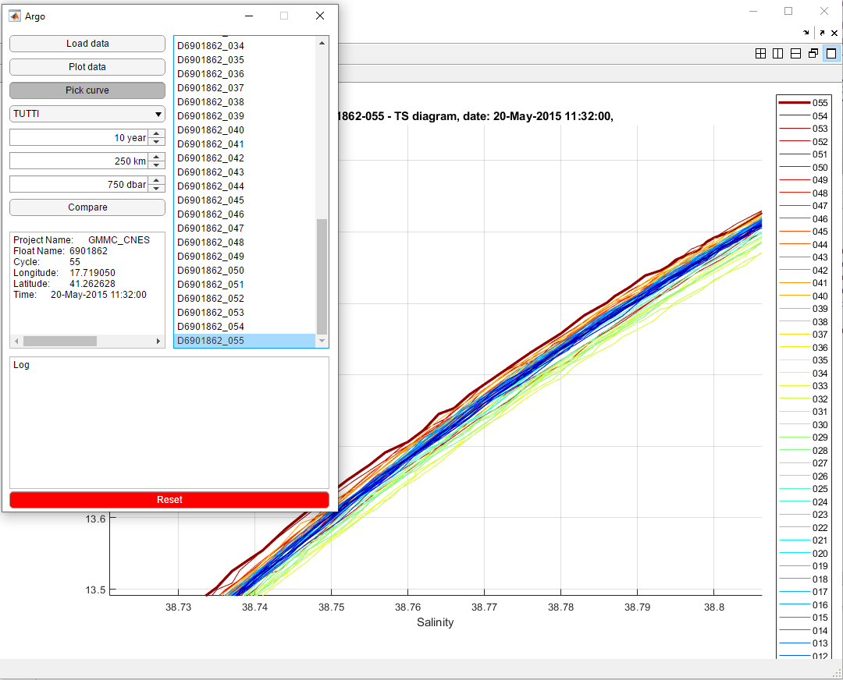

Figure 8: selection of a particular float profile (profile 055 in bold red) in the main dashboard and in the TS diagram.

The selected profile is highlighted in the dashboard and is depicted as a bold line in the TS diagram (profile 055 in this example). The main profile information is given in the middle-left part of the main dashboard.

The float profile can also be compared to a reference dataset. The comparison criteria can be defined on the left side of the main dashboard: the user has to select the sub-basin in which the float profile is located, the maximal distance in time and space between the float and the reference profiles, and the minimal depth of the reference profiles (Figure 9).

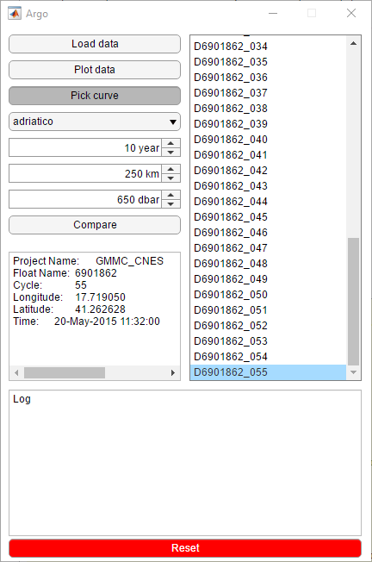

Figure 9: setting up the thresholds for the comparison between the selected float profile and the reference dataset.

Once the criteria have been defined, the comparison is done by clicking the “Compare” button. Several figure are produced:

1. Location of the float profile (black diamond) and location of the reference profiles, color-coded per time difference with the float profile (Figure 10);
2. Float and reference salinity profiles color-coded as defined before (Figure 11);
3. Float and reference TS profiles color-coded as defined before (Figure 12);
4. Salinity float profile (black line) and the closest (in time) reference profile (red line) (Figure 13);
5. TS float profile (black line) and the closest (in time) reference profile (red line) (Figure 14);
6. Location of the float profile (black diamond) and the closest (in time) reference profile (red diamond) (Figure 15);
7. Salinity float profile (black line) and the closest (in space) reference profile (red line) (Figure 16);
8. TS float profile (black line) and the closest (in space) reference profile (red line) (Figure 17);
9. Location of the float profile (black diamond) and the closest (in space) reference profile (red diamond) (Figure 18);

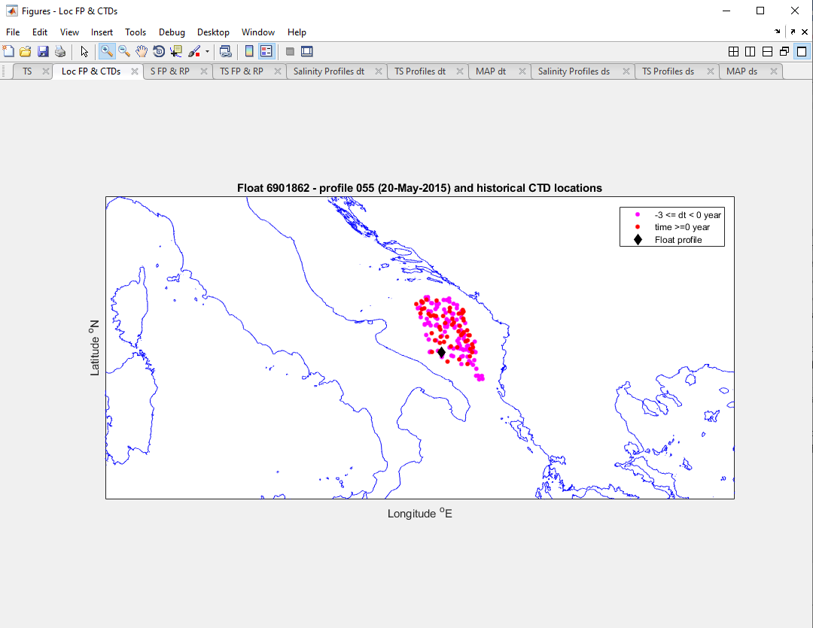

Figure 10: location of the float profile (black diamond) and location of the reference profiles, color-coded per time difference with the float profile.

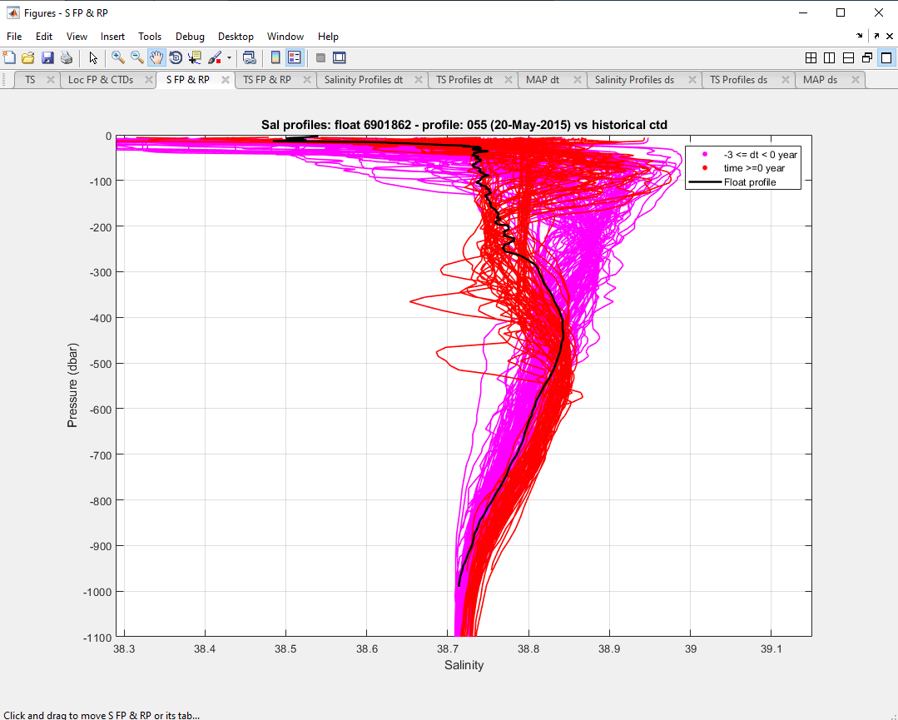

Figure 11: float and reference salinity profiles color-coded as defined in figure 10.

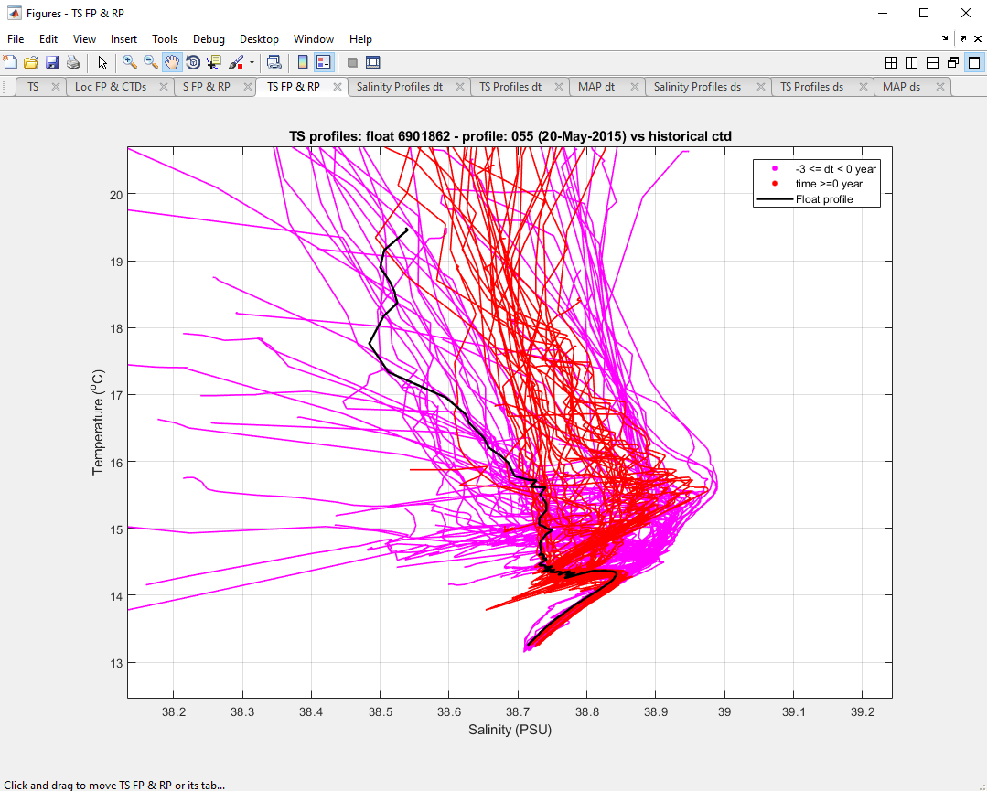

Figure 12: float and reference TS profiles color-coded as defined in figure 10.

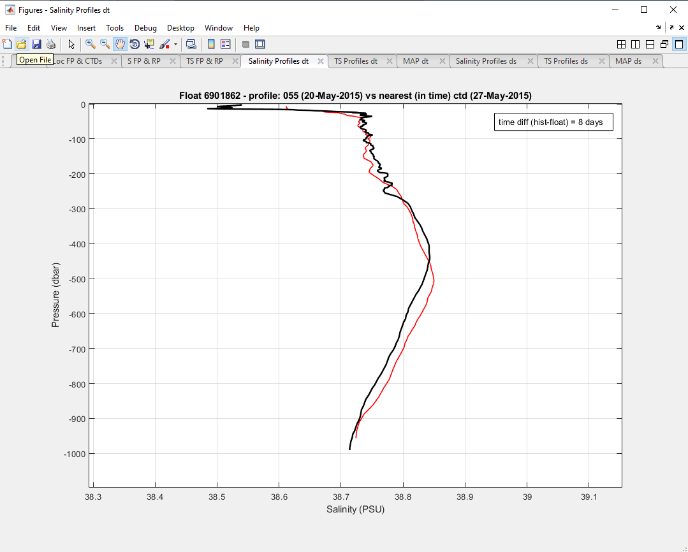

Figure 13: salinity float profile (black line) and the closest (in time) reference profile (red line).

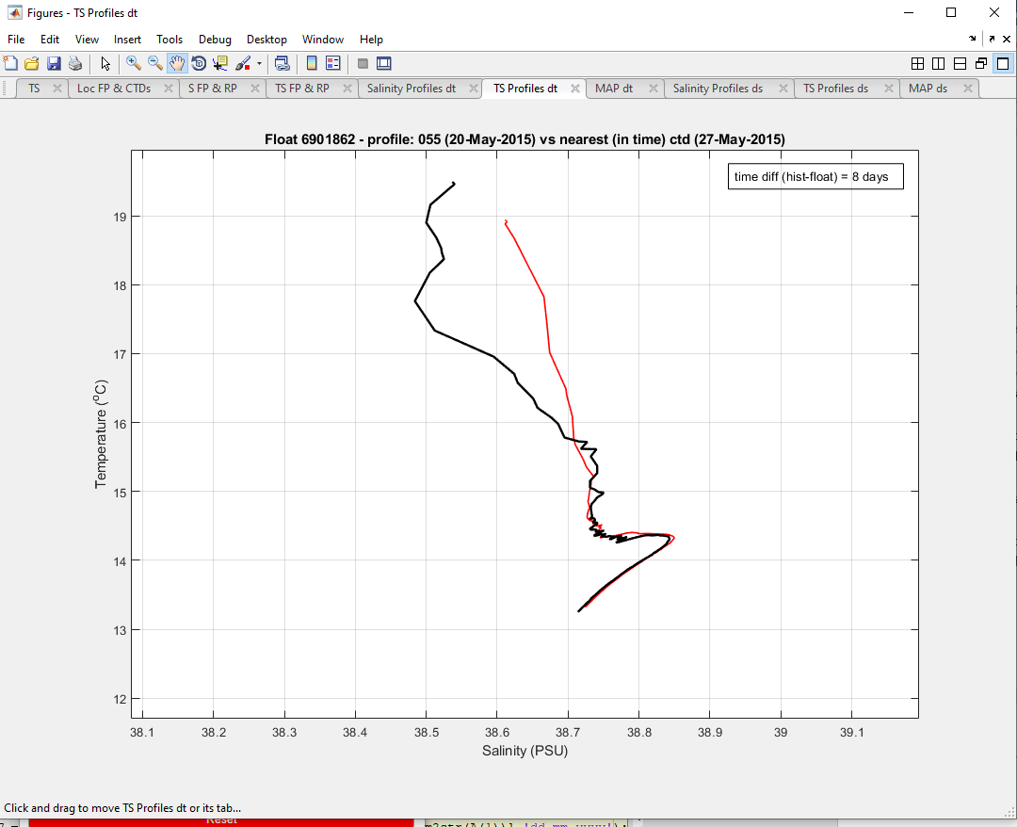

Figure 14: TS float profile (black line) and the closest (in time) reference profile (red line).

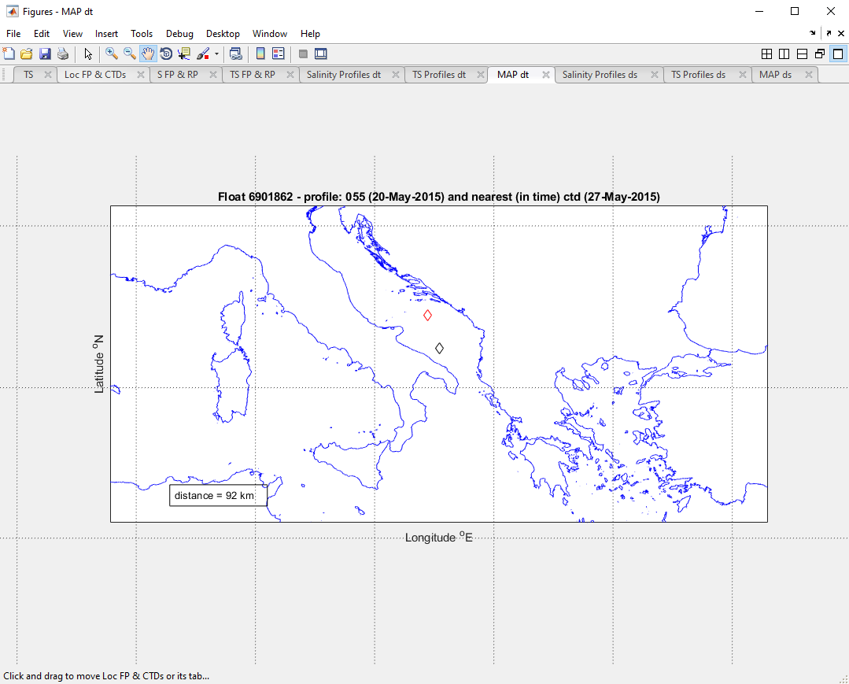

Figure 15: location of the float profile (black diamond) and the closest (in time) reference profile (red diamond).

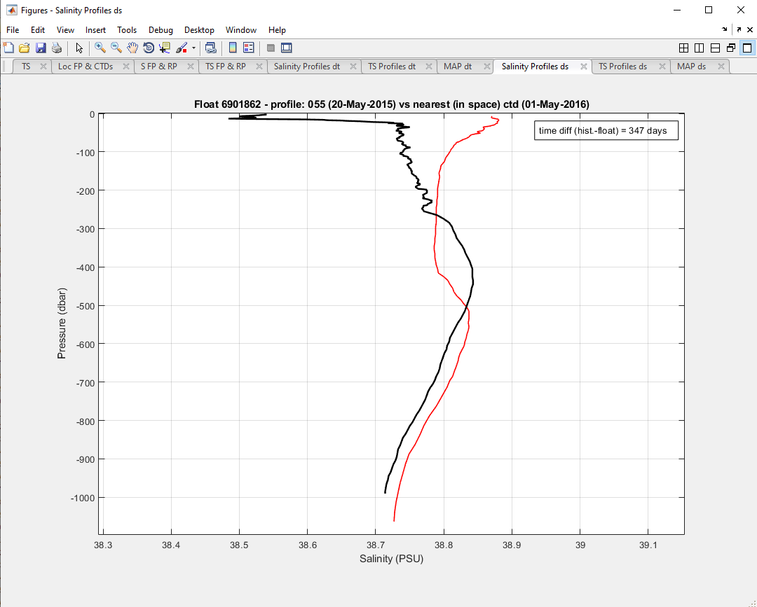

Figure 16: salinity float profile (black line) and the closest (in space) reference profile (red line).

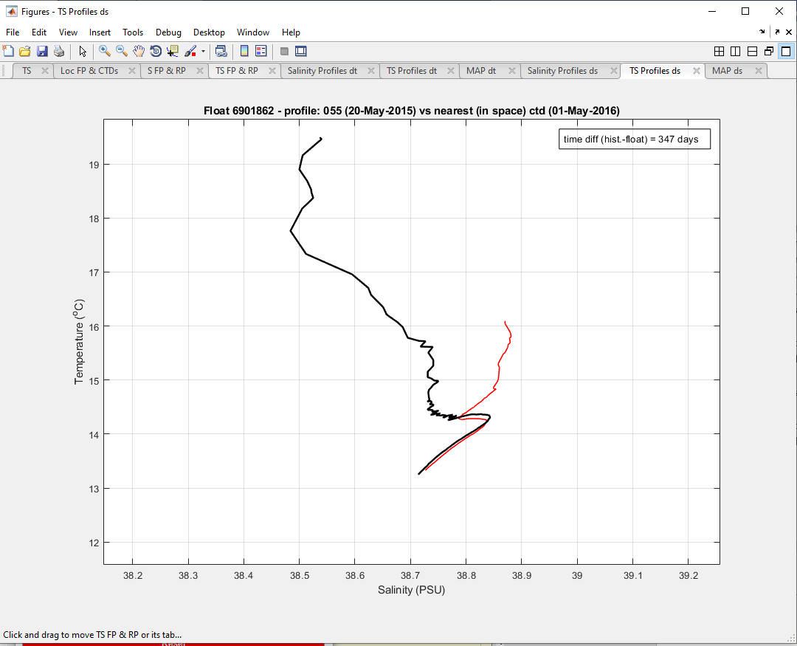

Figure 17: TS float profile (black line) and the closest (in space) reference profile (red line).

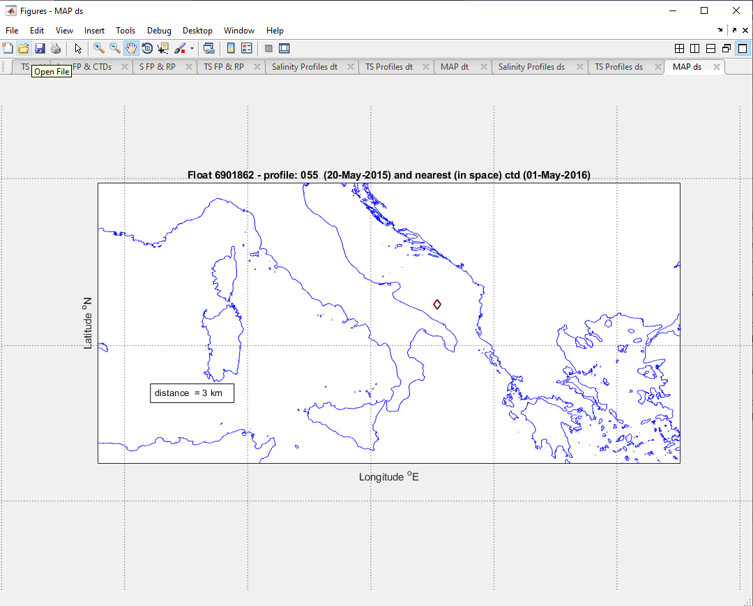

Figure 18: location of the float profile (black diamond) and the closest (in space) reference profile (red diamond).

# Conclusion

The AA is helpful for having a quick view of the float behavior before using the OW software and to check the consistency of the delayed-mode profiles. In particular, the float salinity profiles can be rapidly visualized and compared to the closest reference profiles to look for any potential drift or offset of the conductivity sensor. In this way, the DMQC operator can better organize his work, giving the priority to the floats that need to be checked sooner. The AA is in beta version and hence further tests and improvements are needed.

1. As indicated in the "Technical and Scientific description of the Euro-Argo ERIC" April 2018 attached to the

   Euro-Argo Statutes.
2. Integers correspond to submitted versions.